CAS PY 106

Prelecture Note 15

1. Observing a charge in a magnetic field
2. Force exerted on a charge in an electric field is given by

F = qE

1. Is there an equivalent equation for the force exerted on charge in magnetic field?
2. Magnetic field has the symbol of B, with unit of tesla (T)
3. 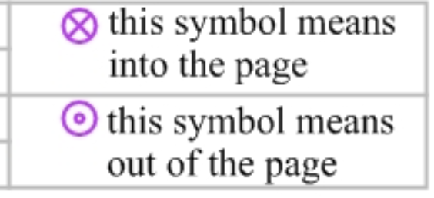
4. Observing a charge in a magnetic field
5. Magnetic fields exert no force on stationary charges, or on charges with velocities directed parallel to the field
6. Magnetic fields exert no force on neutral particles
7. Magnetic force is perpendicular to both magnetic field and velocity of charge
8. The force exerted on a positive charge is opposite to that exerted on a negative charge
9. The force on a charged particle is perpendicular to the velocity and the field. In this special case where velocity and field are perpendicular to one another, we get uniform circular motion
10. Magnetic field is directed out of screen:
11. 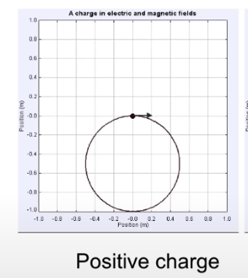
12. 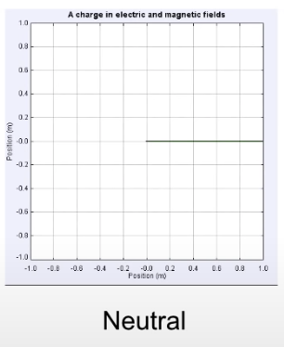
13. 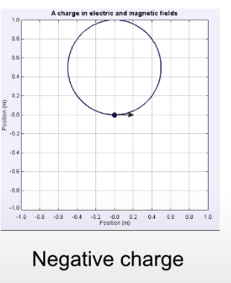
14. The magnetic field is proportional to the force (doubling magnetic field doubles force)
15. The force is proportional to the charge (doubling the charge doubles the force)
16. The force is proportional to velocity
17. Magnetic field force
18. F = q \* v \* B \* sin(theta), where theta is the angle between velocity vector v and magnetic field B
19. Direction of force, which is perpendicular to both v and B, is given by the right-hand rule
20. Something to keep in mind
21. Force perpendicular to velocity, such as magnetic force, cannot change an object’s speed (or kinetic energy)

* Particle’s speed is constant as it moves through a uniform magnetic field
* Kinetic energy of particle is constant since the velocity is constant

1. All it can do is to make object change direction
2. Right hand rule
3. Point the fingers of your right and in direction of velocity
4. Curl your fingers into direction of magnetic field (if v and B are perpendicular, pointing your palm in direction of the field will orient your hand properly)
5. Stick out your thumb, and your thumb points in direction of the force experienced by positive charge
6. If charge is negative, your right-hand lies to you. In that case, the force is opposite to what your thumb says
7. 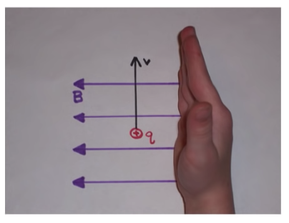🡪🡪🡪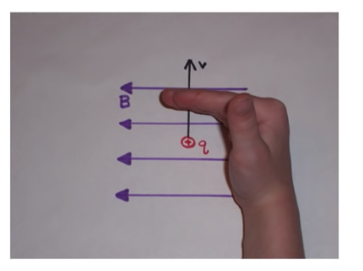
8. Uniform circular motion
9. Force, in uniform circular motion is mv^2/r
10. When velocity of charged particle is perpendicular to magnetic field and field is uniform, the particle experiences uniform circular motion

mv^2/r = qvBsin(theta) where theta is 90 degrees

mv^2/r=qvB

r = mv/qB (radius of the circle)

1. Period of the circle

T = 2\*pi\*r/v

r = mv/qB

T = 2 \* pi \* m / qB